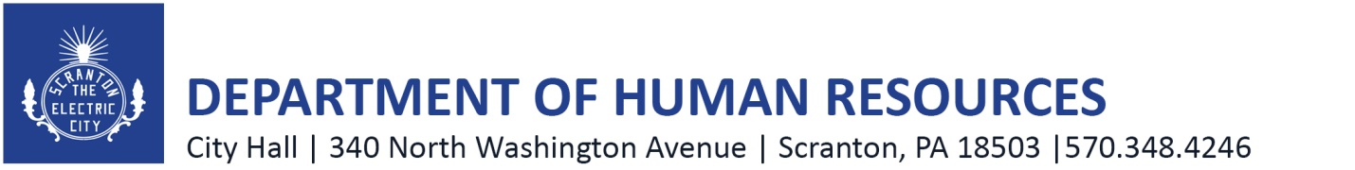

JOB DESCRIPTION

Title: Communication and Information Manager

Department: Community Development

Supervisor: ARP Director

Date: May 16, 2022

General Description:

Under the direction of the ARPA Director, this position will coordinate, execute, monitor, and measure the City’s online platform and communications efforts regarding its use of ARP Funds, performing a range of specialized and administrative duties in the agency’s Community Development Department. The individual should be an excellent writer and have experience in social media graphic design and online technology platforms. The ideal candidate will be a team player who is energetic, organized, creative, and self-motivated to join our busy ARPA team. The position will ensure the City of Scranton will have thorough engagement and awareness concerning the ARPA funding. These efforts are a requisite of the ARPA allocation.
Essential Job Functions:

- Working with the ARP Director on communications, marketing, public relations, education and outreach related to the City’s ARP Fund programming, events, and initiatives;
- Configuring, developing content and applications for ARPA funding in the Open Gov Platform.
- Data tracking and Dashboard development.
- Writing and editing of media stories, news articles, press releases, and written program materials for ARP related initiatives and projects;
- Collaborate with the Director to write and update website content, newsletters, and public education and outreach;
- Preparation of graphic design materials for ARP programming and initiatives;
- Working directly with Director to identify and execute project needs and specifications;
- Preparation of marketing materials for programming related to ARP Funds;
- Maintaining accurate content and design, for the City’s website as well as the City’s OpenGov platform to promote public transparency of ARP Fund uses and programming;
- Photo and Video preparation and editing for ARP related materials;
- Preparation and posting of social media content related to ARP expenditures and programming;
- Assisting the Director with reporting requirements for ARP Funds; and
- Performing related work as may be required.

Required Training, Experience, Knowledge, Skill, and Abilities:
- Bachelor’s degree or at least three (3) years’ experience in public relations, communications, marketing, and social media management;
- Prior press experience preferred;
- Professional social media experience is preferred;
- Experience creating content for and managing campaigns across multiple social media platforms to include Facebook, Twitter, Instagram, LinkedIn, and YouTube;
- Experience with social media management;
- Experience with graphic design concepts and tools;
- Working knowledge of website content management;
- Microsoft Office experience required;
- Strong writing, editing, proofreading and layout/design skills are essential;
- High degree of problem-solving abilities;
- Ability to prioritize and work independently with minimal supervision;
- Outstanding communication skills, both verbal & written; and
- Ability to manage multiple projects and changes in direction, re-prioritizing deliverables as needed.

Nothing in this job description restricts management’s right to assign or reassign duties and responsibilities to this job at any time.

