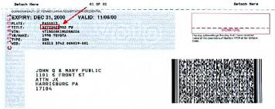

**Please include a copy or a photo of these 3 documents.**

**This is to insure accuracy of your address and the placement of your handicapped parking sign.**

**Please make sure the address on your application matches the address on your vehicle registration card and parking placard ID card.**

