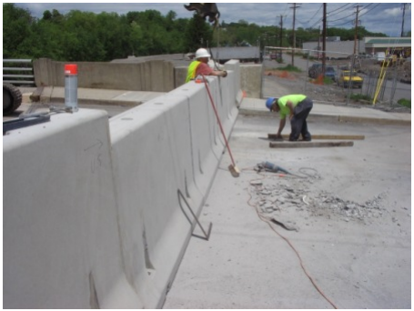
Green Ridge Jersey Barrier Instructions
Materials Needed
- 2 ea lifting devices with cables
- 4 ea brackets
- 8 ea bolts (3/4”-10x2.75 TAP SS)
- 5 ea connecting plates
- Putty knife
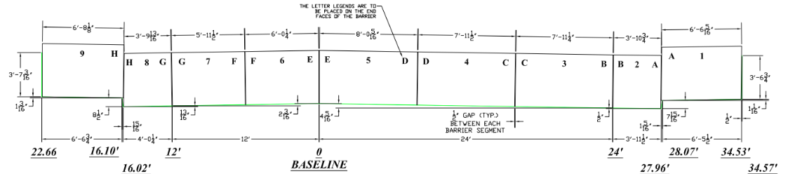
- 1 1/8” socket or crescent wrench
- Rubber tired loader
- Excavator
- 30 CY of #57 stone
- 60 ft of Plastic sheeting 4 ft wide
Procedures
- Install the brackets onto the bridge, allowing the barriers to set on the sidewalk against the clip. Remove the plugs in the anchor inserts and insert stainless steel bolts
- Using the rubber tired loader with forks, move the barriers from the storage area to their approximate final location
- Using a small excavator with cables connected to the lifting devices, place the barriers in their correct position. Barrier #1 should be on the upstream side of the bridge, and barrier #9 on the downstream side.
  - Before placing the rest of the barriers, place 2 4”x4”s vertically against the barrier and slowly push them with the loader until they are tight against the wall
- Install a steel connection plate into barriers #1 and #9
- Install the rest of the jersey barriers in their numbered order. It is important to note that each barrier has a letter matching that of the barrier next to it. Be sure that the letters on each side of the barriers match each other (See the above picture for reference)
- Place #57 stone along the entire landside of the barriers. The stone should be 2.5 feet high and extend landward with a top width of 4.5 ft and a landside slope of 1V:1.5H
- Place heavy duty rubber sheeting on the riverside barriers over the #57 stone and onto the landside of the stone. This sheeting should extend 3ft onto the bridge. Use sandbags along the entire closure to hold sheeting in place.
Digital version of instruction sheet available online – Scan QR Code to Access

