Miter Gate Closure Instructions
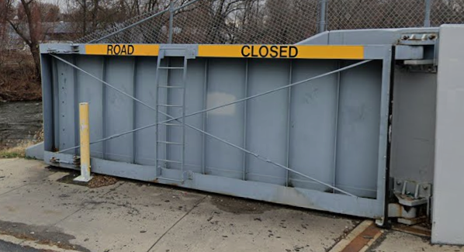
Miter Gate Closures can be fount at: D-L Railroad, Olive St. Bridge, Poplar St. Bridge, Albright Ave. Bridge (Albright side)
Materials Needed
- Welding Torch
- Sandbags
- Tarpaulin (4ft wide)
- 4 ft wide Plastic Sheeting
- Flat Shovel
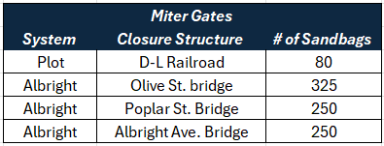
- Bolt Cutters
- Winch
- F450 Truck
Procedures
- Unlock the holds / bollards holding the gate in place. If the locks are frozen, bolt cutters can be used to cut the lock.
- Place filled sandbags on the riverside of the closure.
- If using manpower, Push gates together, ensuring that the rubber seals at the bottom, and the gates themselves are sealed tight.
  - If using Winch, attach winch to the eyebolt at the top of the gate, close until resting on the seal of the gate.
- Fasten the locking mechanisms at the top and bottom of the gate to secure its closed position.
- Check the rubber seals around the perimeter of each gate to assure that a tight fit is made between the seal and the seating surface.
  - Gaps between the seals and seal plates can be sealed by covering with plastic sheeting and weighing the sheeting down with sandbags.
- Riverward of the closure gate, lay the 4-foot-wide tarps or plastic sheeting along the bottom of the gate from one abutment to the other, with two feet of tarp lying on the ground in front of the gate, and two feet lying vertically against the gate.
  - If more than one tarp is used, they should be installed with the upstream section overlapping the downstream section.
- Place sandbags continuously along the tarp to hold it in place, with additional sandbags placed at the overlaps, concrete abutments, and vertically against the gates. A single layer of sandbags placed atop the sheeting should prevent most seepage under the gate.
Digital version of instruction sheet available online – Scan QR Code to Access

