Sandbag Closure Instructions
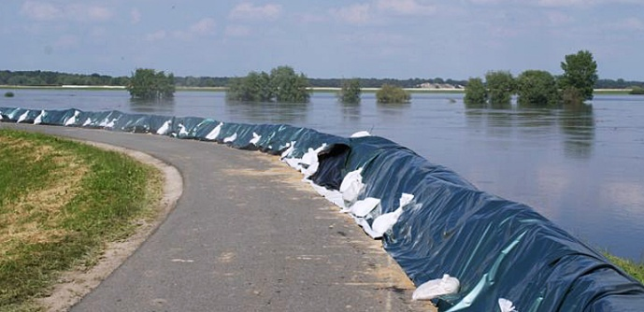
Sandbag Closures can be found at: D&L Railroad bridge – Green Ridge side
Materials Needed
- 200 Sandbags
- 1 100ft roll of 20 mil Plastic Sheeting
- 5-10 shovels
- Approximately 10 Tons of Sand
- 2 Emergency Lights sets
- 6 Pickup Trucks or Similar
Procedures
- While on site, begin filling sandbags. Fill to between 1/2 and 2/3 of their capacity.
- Remove any debris from the ground where the sandbags will be placed
- Place 20 mil plastic sheeting on the ground along the area the sandbags will be placed.
  - Leave the excess sheeting towards the water so that the sandbags on the riverward side will be covered.
- Lay sandbags lengthwise, parallel to the direction of flow
  - The bottom of the bag should face downstream
  - Fold the open ends/tops of the bag on the upstream side under the bag
  - Place the bags tightly against each other and partially overlap the bags
- Build a “pyramid” of sandbags leaving at least a 1-foot gap from the riverward crown
  - The pyramid should be 3-feet wide for every 1-foot of height
  - Stagger bags placed on top to ensure that all gaps are covered
- Pull the plastic sheeting on the riverward side over the sandbags.
  - Either tuck the excess sheeting under the placed sandbags, or place new sandbags on top of the plastic sheeting to hold it in place.
Digital version of this instruction sheet – Scan QR Code to Access

